Hands-on 1:

TDD using JUnit5 and Mockito
Exercise 1:
Setting Up Junit

File name: pom.xml

<project xmlns="http://maven.apache.org/POM/4.0.0"
xmlns:xsi="http://www.w3.org/2001/XMLSchema-instance"
xsi:schemaLocation="http://maven.apache.org/POM/4.0.0
http://maven.apache.org/xsd/maven-4.0.0.xsd">

<modelVersion>4.0.0</modelVersion>

<groupId>com.example</groupId>
<artifactId>Calculator</artifactId>
<version>1.0-SNAPSHOT</version>

<dependencies>

<dependency>
<groupId>org.junit.jupiter</groupId>
<artifactId>junit-jupiter</artifactId>
<version>5.10.0</version>
<scope>test</scope>
</dependency>
</dependencies>

<build>
<plugins>
<plugin>
<groupId>org.apache.maven.plugins</groupId>
<artifactId>maven-surefire-plugin</artifactId>
<version>3.1.2</version>
</plugin>
</plugins>
</build>
</project>

Exercise 3: Assertions in Junit
File name : Calculator.java
package com.example;
public class Calculator {
public int add(int a, int b) {
return a + b;
}
public double divide(int a, int b) {
if (b == 0) throw new IllegalArgumentException("Cannot divide by zero");
return (double) a / b;
}
public boolean isPositive(int num) {
return num > 0;
}
public Integer getNullValue() {
return null;
}
}
File name : CalculatorTest.java
package com.example;

import org.junit.jupiter.api.*;

import static org.junit.jupiter.api.Assertions.*;

public class CalculatorTest {
private Calculator calculator;
@BeforeEach
void setUp() {
calculator = new Calculator();
}
@AfterEach
void tearDown() {
System.out.println("Test finished.");
}
@Test
void testAddition() {
assertEquals(9, calculator.add(4, 5));
}
@Test
void testDivision() {
assertEquals(2.5, calculator.divide(5, 2), 0.001);
}
@Test
void testDivisionByZero() {
assertThrows(IllegalArgumentException.class, () -> calculator.divide(10, 0));
}
@Test
void testIsPositive() {
assertTrue(calculator.isPositive(7));
assertFalse(calculator.isPositive(-1));
}
@Test
void testGetNullValue() {
assertNull(calculator.getNullValue());
}
}

OUTPUT:
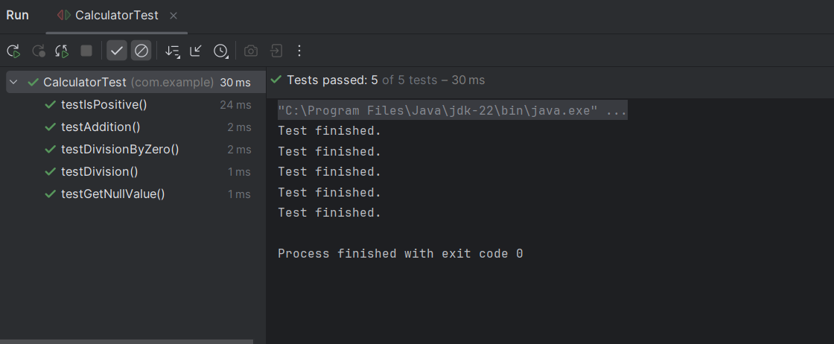

Exercise 4:
Arrange-Act-Assert (AAA) Pattern, Test Fixtures, Setup and Teardown methods in JUnit:

File name : CalculatorTest.java
package com.example;
import org.junit.jupiter.api.*;
import static org.junit.jupiter.api.Assertions.*;
public class CalculatorTest {
private Calculator calculator;
@BeforeAll
public static void init(){
System.out.println("Calculator testing started");
}
@AfterAll
public static void cleanAll(){
System.out.println("All test completed");
}
@BeforeEach
void setUp() {
calculator = new Calculator();
}
@AfterEach
void tearDown() {
System.out.println("Test finished.");
}
@Test
void testAddition() {
//Arrange
int a =10;
int b=20;
//Act
int result=calculator.add(a , b);

//Assert

assertEquals(30 , result);
}
@Test
void testDivision() {
//Arrange
int a=20;
int b=10;

//Act
double result=calculator.divide(a , b);

//Assert
assertEquals(2 , result);
}
@Test
void testIsPositive() {
assertTrue(calculator.isPositive(7));
assertFalse(calculator.isPositive(-1));
}

@Test
void testGetNullValue() {
assertNull(calculator.getNullValue());
}

OUTPUT: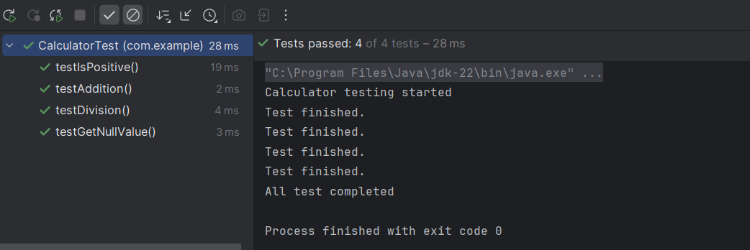

Mokito Exercises :
Exercise 1: Mocking and Stubbing :
File name : WeatherService.java
(Acts as an external Api)

package com.example;

public interface WeatherService {
String getForecast(String city);
}

File Name: WeatherReporter.java

package com.example;

public class WeatherReporter {
private final WeatherService weatherService;
public WeatherReporter(WeatherService weatherService) {
this.weatherService = weatherService;
}

public String report(String city) {
String forecast = weatherService.getForecast(city);
return "Weather report for " + city + ": " + forecast;
}

}

File Name :WeatherReportTesting
package com.example;

import org.junit.jupiter.api.BeforeEach;
import org.junit.jupiter.api.Test;
import static org.mockito.Mockito.*;
import static org.junit.jupiter.api.Assertions.*;

public class WeatherReportTesting {

private WeatherService mockWeatherService;
private WeatherReporter reporter;

@BeforeEach
void setUp() {
mockWeatherService = mock(WeatherService.class);
reporter = new WeatherReporter(mockWeatherService);
}

@Test
void testWeatherReport_forChennai() {
// Stub the mock
when(mockWeatherService.getForecast("Chennai")).thenReturn("Sunny, 35°C");

// Act
String report = reporter.report("Chennai");

// Assert
assertEquals("Weather report for Chennai: Sunny, 35°C", report);

verify(mockWeatherService, times(1)).getForecast("Chennai");
}

@Test
void testWeatherReport_forDelhi() {
when(mockWeatherService.getForecast("Delhi")).thenReturn("Cloudy, 28°C");
String report = reporter.report("Delhi");
assertEquals("Weather report for Delhi: Cloudy, 28°C", report);
verify(mockWeatherService).getForecast("Delhi");
}
}

OUTPUT:
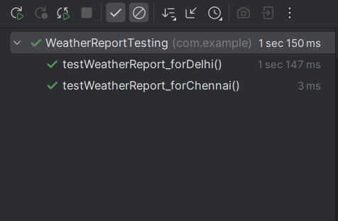

Exercise 2: Verifying Interactions:

File name: WeatherReporter.java
package com.example;
public class WeatherReporter {
private final WeatherService service;
public WeatherReporter(WeatherService service) {
this.service = service;
}
public String report(String city) {
return "Report: " + service.getForecast(city);
}
}
File name: WeatherReportTesting.java
package com.example;
import com.example.WeatherReporter;
import com.example.WeatherService;
import org.junit.jupiter.api.BeforeEach;
import org.junit.jupiter.api.Test;
import static org.mockito.Mockito.*;
import static org.junit.jupiter.api.Assertions.*;
public class WeatherReportTesting {
private WeatherService mockService;
private WeatherReporter reporter;
@BeforeEach
void setUp() {
mockService = mock(WeatherService.class);
reporter = new WeatherReporter(mockService);
}
@Test
void testMockInteraction() {
// Arrange (Stubbing)
when(mockService.getForecast("Delhi")).thenReturn("Cloudy");
// Act
String result = reporter.report("Delhi");
// Assert return value
assertEquals("Report: Cloudy", result);

// Verify interaction with mock
verify(mockService).getForecast("Delhi");

// Verify it was called only once
verify(mockService, times(1)).getForecast("Delhi");

// Verify no other method was called
verifyNoMoreInteractions(mockService);
}
}
OUTPUT:
